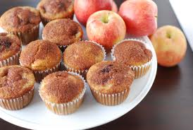
Apple Muffins
2 cups sugar
2 eggs
1 cup oil
1 Tablespoon vanilla
3 cups flour
1 teaspoon salt
1 teaspoon baking soda
1 teaspoon cinnamon
3 cups peeled, cored, diced apples (around 3 apples)
Brown sugar for topping (around ½ cup)

Instructions:
- Preheat oven to 350 degrees and line muffin pan with sprayed paper liners
- Cream together sugar, eggs, oil, and vanilla. Stir in flour, baking soda, salt, and cinnamon and mix until combined. The batter will be very thick.
- Add diced apples and stir
- Fill paper liners almost to the top, about 3.4 of the way full. Sprinkle with brown sugar.
- Bake at 350 for 20-24 minutes. Makes 18 muffins.

